***Infrared Sensor (GP2Y0A21YK0F)***

Size: 30 x 13 x 14 mm (length x wide x high)

Range of Working Voltage: 4.5V-5.5V

Working Range: 10cm – 80cm

Length of Feet: 23mm

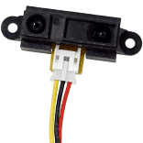

Pins From left to right: DataOut, GND, Vcc